**WEEK 10**

**(A)AIM:** To write a Java program that simulates a traffic light.

**THEORY:** The AWT supports a rich assortment of graphics methods. All graphics are drawn relative to a window. These can the main window of an applet, a child window of an applet, or a stand-alone application window. The origin of each window is at the top-left corner and is 0,0 coordinates are specified in pixels. All output to a window takes place through graphics context.

**ALGORITHM:**

STEP1: START

STEP2: Create an applet using extends Applet class.

STEP3: Create three checkboxes for red, orange and green and make them into one group.

STEP4: Implement the itemStateChanged() method whenever the checkbox selection is changed.

STEP5: Draw three ovals initially filled with black.

STEP6: Fill the ovals with appropriate colors on the selection of checkbox.

STEP7: Display the appropriate message beside the filled oval.

STEP8: END

**SOURCE CODE:**

import java.applet.Applet;

import java.awt.*;

import java.awt.event.*;

public class Traffic extends Applet implements ItemListener {

int columnNum;

String msg;

CheckboxGroup cg;

Checkbox red,yellow,green;

public void init() {

cg=new CheckboxGroup();

red=new Checkbox("Red",cg,true);

yellow=new Checkbox("Yellow",cg,true);

green=new Checkbox("Green",cg,true);

add(red);

add(yellow);

add(green);

red.addItemListener(this);

yellow.addItemListener(this);

green.addItemListener(this);

}

public void itemStateChanged(ItemEvent e)

{

if(e.getSource()==red)

{

columnNum=1;

}

else if(e.getSource()==yellow)

{

columnNum=2;

}

else{

columnNum=3;

}

repaint();

}

public void paint(Graphics g)

{

g.setColor(Color.black);

g.fillOval(100,100,50,50);//red light

g.fillOval(100,170,50,50);//yellow light

g.fillOval(100,230,50,50);//green light

switch(columnNum)

{

case 1:g.setColor(Color.red);

g.fillOval(100,100,50,50);

msg="Stop";

g.setColor(Color.red);

g.drawString(msg,180,110);

break;

case 2:g.setColor(Color.yellow);

g.fillOval(100,170,50,50);

msg="Ready";

g.setColor(Color.red);

g.drawString(msg,180,180);

break;

case 3:g.setColor(Color.green);

g.fillOval(100,230,50,50);

msg="Go";

g.setColor(Color.red);

g.drawString(msg,180,240);

break;

}

}

}

**OUTPUT:**

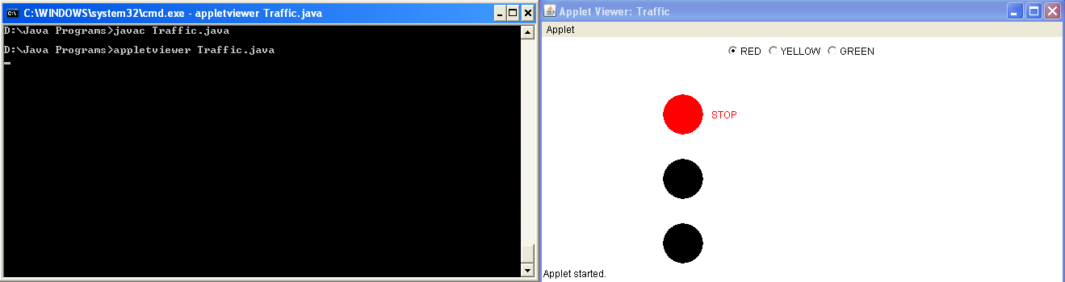

**VIVA - VOCE:**

1. What is a Checkbox?

The Checkbox class is used to create a checkbox. It is used to turn an option on (true) or off (false). Clicking on a Checkbox changes its state from "on" to "off" or from "off" to "on".

2. What is a CheckboxGroup?

The object of CheckboxGroup class is used to group together a set of Checkbox. At a time only one check box button is allowed to be in "on" state and remaining check box button in "off" state. It inherits the object class.

3. What is the use of itemStateChanged()?

The itemStateChanged() method is invoked automatically whenever you click or unclick on the registered checkbox component.

4. What is the purpose of Graphics class?

It's essential that programmers understand the Graphics class before they attempt to draw images via Java. The Graphics class provides the framework for all graphics operations within the AWT. Because the Graphics class is an abstract base class, it cannot be instantiated directly.

5. What is the purpose of AWT?

Java AWT (Abstract Window Toolkit) is an API to develop GUI or window-based applications in java. Java AWT components are platform-dependent i.e. components are displayed according to the view of operating system. AWT is heavyweight i.e. its components are using the resources of OS. he java.awt package provides classes for AWT api such as TextField, Label, TextArea, RadioButton, CheckBox, Choice, List etc.